**I am using someone’s VIPER**

TASK 1:

#include<iostream>

using namespace std;

int main()

{

int a=20;

int *p;

p = &a;

cout << *p << endl; //displaying value

system("pause");

}

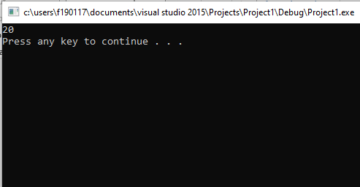

Task 2;

#include<iostream>

using namespace std;

int main()

{

int a=10, b=20;

int *p;

int *p1;

p = &a;

p1 = &b;

cout << "Adding a and b using pointer :";

cout << *p + *p1 << endl; //displaying value

system("pause");

}

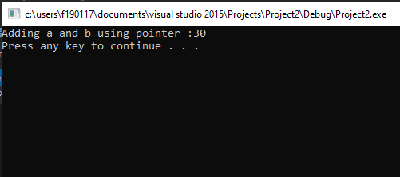

Task 3:

#include<iostream>

using namespace std;

int main()

{

//declaring and initializing values

int a = 10, b = 20;

int *p;

int *p1;

int z;

p = &a;

p1 = &b;

//displaying values before swaping

cout << "Value of a is :" << *p<<endl;

cout << "Value of b is :" << *p1 << endl;

//swaping values using pointer

z = *p;

*p = *p1;

*p1 = z;

//displaying values before swaping

cout << "Value of a is :" << *p << endl;

cout << "Value of b is :" << *p1 << endl;

system("pause");

}

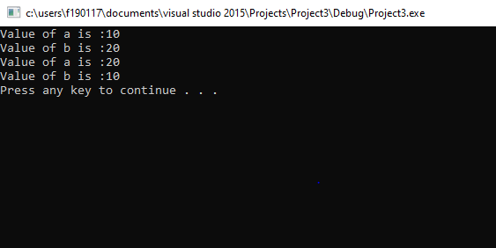

Task 4:

#include<iostream>

using namespace std;

int main()

{

int array1[5] ;

int *p;

p = array1;

for (int i = 0; i < 5; i++)

{

cin >> *(p + i);

}

for (int i = 0; i < 5; i++)

{

cout << *(p)<<endl;

p++;

}

system("pause");

}

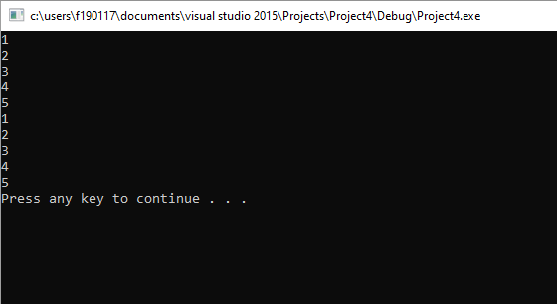

Task 5;

#include<iostream>

using namespace std;

int main()

{

int array1[5];

int array2[5];

int *p;

int *p1;

p = array1;

p1 = array2;

for (int i = 0; i < 5; i++)

{

cin >> *(p + i);

}

for (int i = 0; i < 5; i++)

{

*(p1 + i) = *(p + i);

}

for (int i = 0; i < 5; i++)

{

cout << *(p1) << endl;

p1++;

}

system("pause");

}

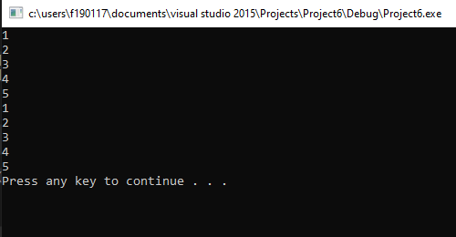

Task 6;

#include<iostream>

using namespace std;

int main()

{

int array1[5] = {1,2,3,4,5};

int array2[5] = {6,7,8,9,10};

int *p;

int *p1;

p = array1;

p1 = array2;

cout << "values of array "<<endl;

cout << "array1";

for (int i = 0; i < 5; i++)

{

cout << *(p + i)<<endl;

}

cout << "array2";

for (int i = 0; i < 5; i++)

{

cout << *(p1 + i)<<endl;

}

for (int i = 0; i < 5; i++)

{

int temp = *(p + i);

*(p + i) = *(p1 + i);

*(p1 + i) = temp;

}

cout << "values of array after swapping "<<endl;

cout << "array1";

for (int i = 0; i < 5; i++)

{

cout << *(p + i)<<endl;

}

cout << "array1";

for (int i = 0; i < 5; i++)

{

cout << *(p1 + i)<<endl;

}

system("pause");

}

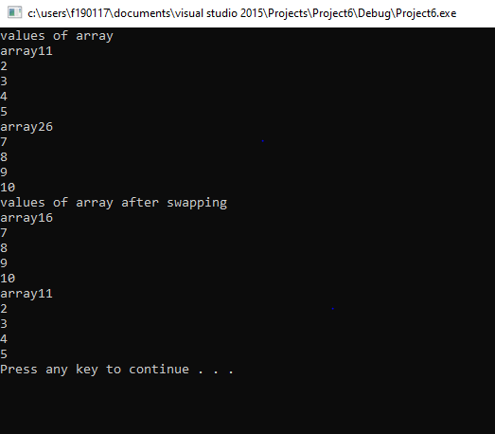

Task 7:

#include<iostream>

using namespace std;

int main()

{

int array1[5] = {1,2,3,4,5};

int *p;

p = array1;

for (int i = 4; i >=0 ; i--)

{

cout << *(p + i)<<endl;

}

system("pause");

}

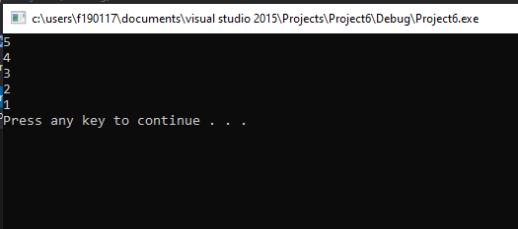

Task 8:

#include<iostream>

using namespace std;

int main()

{

int array1[5]={1,2,3,4,5};

int *p;

int num;

p=array1;

cout<<"Enter element of array";

cin>>num;

for(int i=1;i<=5;i++)

{

if(*(p+i)==num)

{

cout<<"Number is found on the index "<<i<<endl;

}

}

}

}

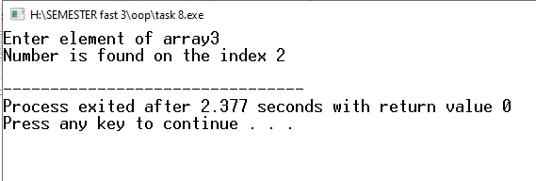

Task 12:

#include<iostream>

using namespace std;

int main()

{

char str[50]={"instant"};

char *p;

p=str;

int temp=0;

while(*p!='\0')

{

temp++;

p++;

}

cout<<"The number of elements in string is "<<temp<<endl;

return 0;

}

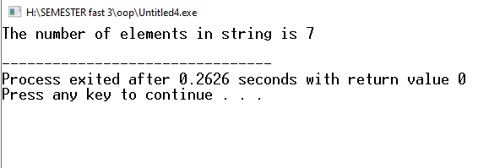

Task 13:

#include<iostream>

using namespace std;

int main()

{

char str[20]={"Resistance"};

char str1[20];

char *p;

char *p1;

p=str;

p1=str1;

cout<<"The number after asigning is ";

for(int i=0;i<20;i++)

{

*(p1+i)=*(p+i);

}

for(int i=0;i<20;i++)

{

cout<<*(p1+i)<<endl;

}

}

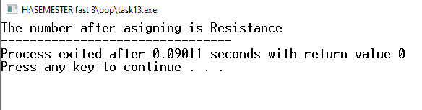

Task 14:

#include <iostream>

using namespace std;

int main ()

{

char str [20]="saad";

char str1 [20]="Iqbal";

char sub [20];

char *p1;

char *p2;

char *p3;

p1= str;

p2= str1;

p3 = sub;

while ((*p1 != '\0'))

{

*p3 = *p1;

p3++;

p1++;

}

while (*p2!='\0')

{

*p3=*p2;

p3++;

p2++;

}

p3 = conc;

while (*p3!='\0')

{

cout << *p3;

p3++;

}

}

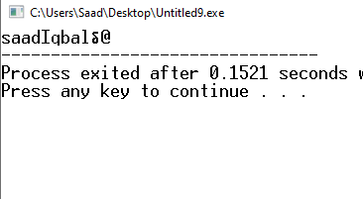

TASK 15:

#include<iostream>

using namespace std;

int main()

{

char chr[10];

char chr2[10];

char *p1 , *p2 ;

int count = 0 , count2 = 0 , equal = 0;

cout << "please enter the first string : ";

p1 = chr;

cin.getline(chr,10);

cout << "please enter the second string : ";

p2 = chr2;

cin.getline(chr2,10);

for(int i = 0 ; *(p1+i)!= '\0'; i++)

{

count++;

}

for(int i = 0 ; *(p2+i)!= '\0'; i++)

{

count2++;

}

for(int i = 0 ; *(p2+i)!= '\0'; i++)

{

if(*(p1+i) == *(p2+i))

{

equal++;

}

}

if(count == count2)

{

cout << " the strings are equal in size ";

}

else

{

cout << " the strings are not equal in size ";

}

cout << "\nthe letters which are equal are = " << equal ;

}

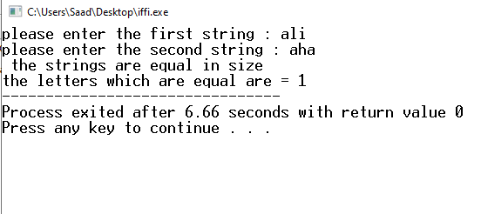

Task 16:

// Program to reverse string using pointers

#include<iostream>

using namespace std;

int main()

{

char arr[20] , chr , *ptr;

int count = 0 ;

// To get input with spaces

cout <<"Enter the string you want to reverse backward : ";

cin.getline(arr , 20);

// To copy the address of array into pointer

ptr = arr;

// To find the length of string

for (int counter = 0 ; *(ptr + counter) != '\0' ; counter++)

{

if(arr[counter] >65 || arr[counter] == 32)

{

count++;

}

}

cout << "\n\n\tThe reverse of a string is : ";

// To print the reverse of string

for (int counter = count ; counter >=0 ; counter--)

{

if(arr[counter] >65 || arr[counter] == 32)

{

cout << *(ptr + counter);

}

}

cout << endl;

}

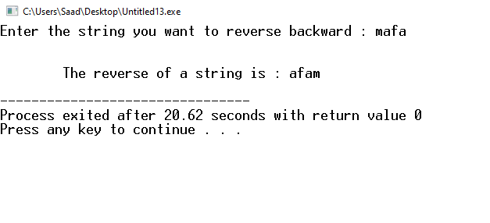

Task 17:

#include<iostream>

using namespace std;

const int size = 10;

int array[size] , array2[size];

int *ptr ;

void selection_sort(int *ptr )

{

for (int count = 0 ; count < size ; count++)

{

for (int counter = count + 1 ; counter < size ; counter++)

{

if ( *(ptr+count) > *(ptr+counter) )

{

*(ptr+count) = *(ptr+count) + *(ptr+counter);

*(ptr+counter) = *(ptr+count) - *(ptr+counter);

*(ptr+count) = *(ptr+count) - *(ptr+counter);

}

}

}

for (int count = 0 ; count < size ; count++)

{

array2[count] = *(ptr+count);

}

}

int main()

{

cout << "Plese enter the elements := ";

for(int input = 0 ; input < size ; input++)

{

cin >> array[input];

}

ptr = array;

selection_sort(ptr);

for(int input = 0 ; input < size ; input++)

{

cout << array2[input] <<" ";

}

}

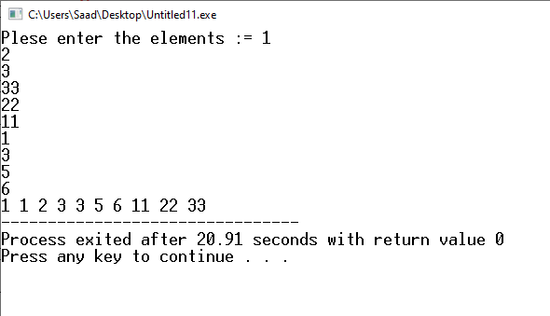

Task 18:

#include<iostream>  
using namespace std;  
int i = 2  ;  
int print()  
{  
int *p , a = 1;  
p = &a;  
return *p * i;  
  
}  
   
int main()  
{  
cout << "Returned value is := ";  
while(i < 10 )  
{  
cout <<  print() <<" ";  
i++;  
}  
}

